How to replace the TV HPA pallet UHF/VHF

- Take cover off top of amp 10 screws.
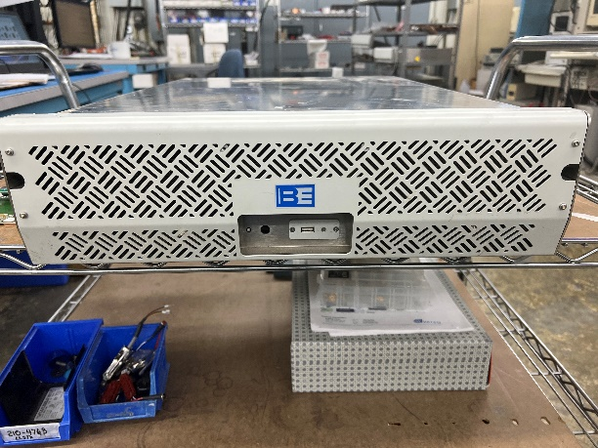
Front
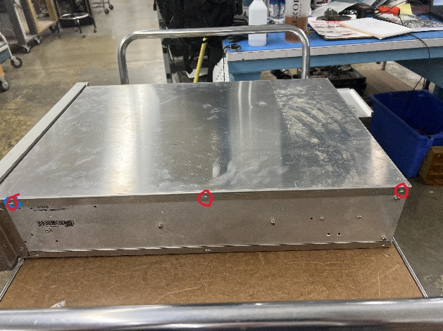
Right side
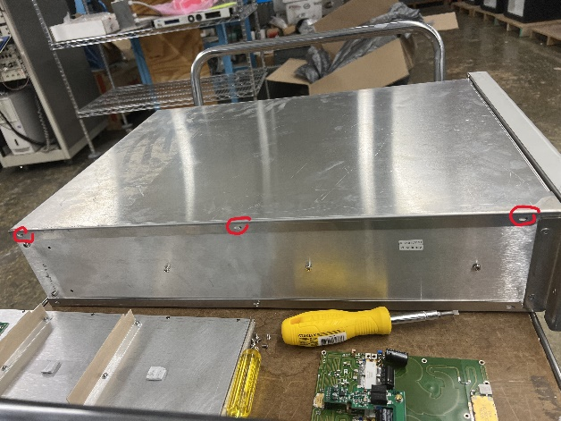
Left side
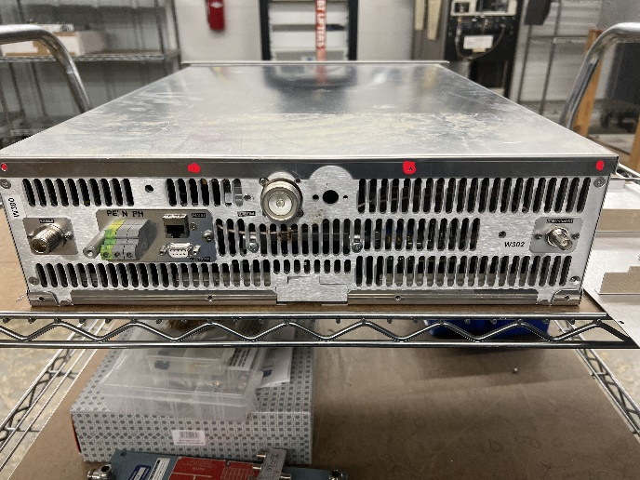
Back

- Take screw off pallet cover:
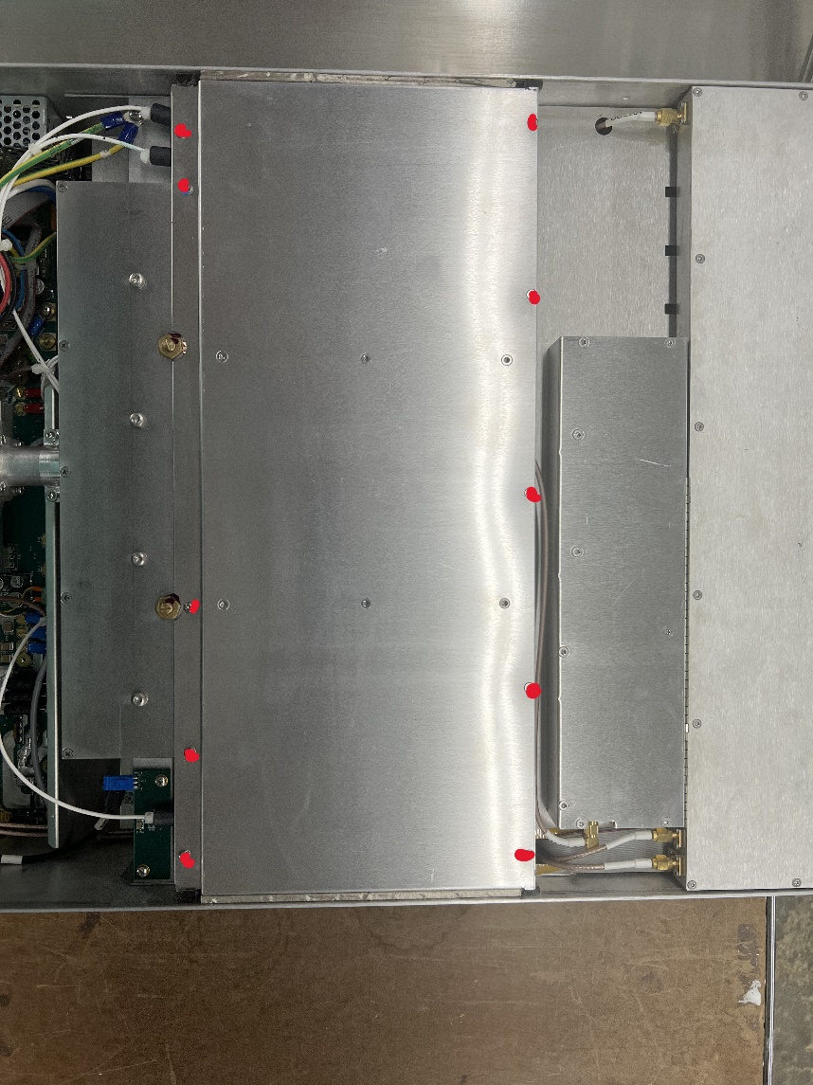
10 screws
- After cover is off take the power bridge off.
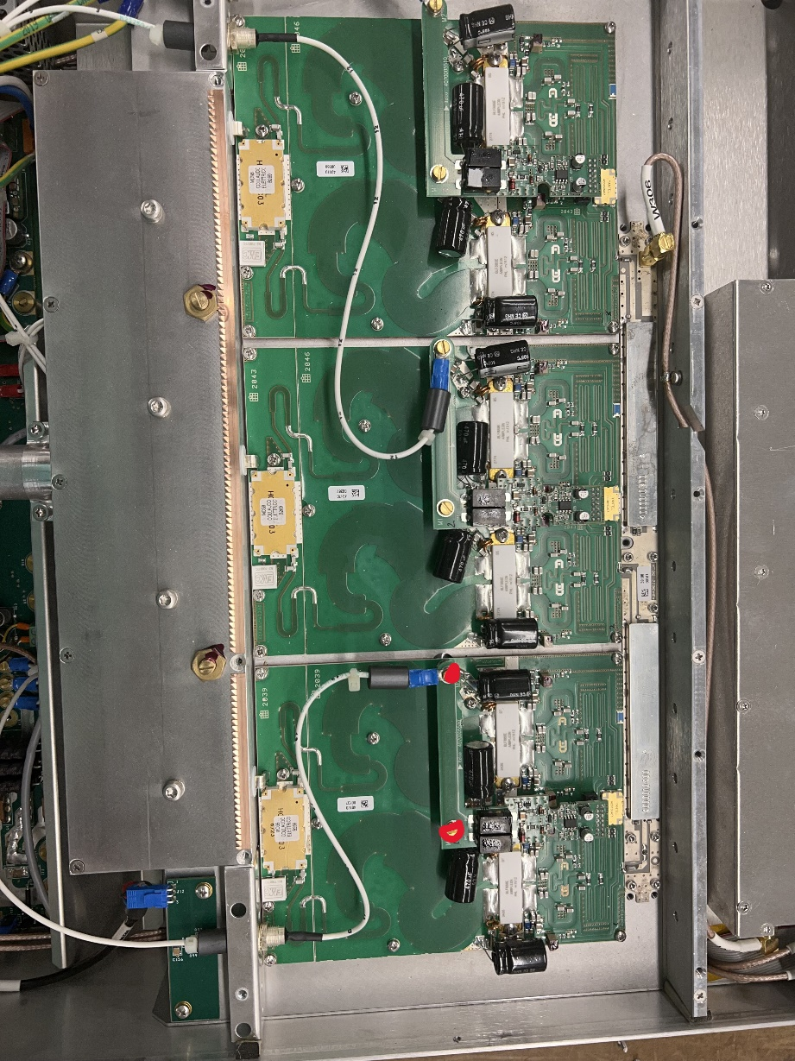
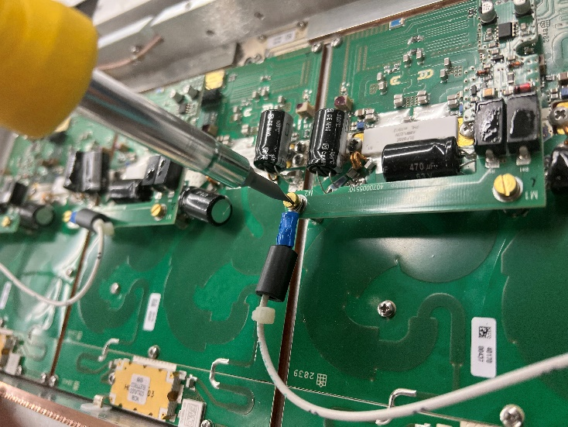
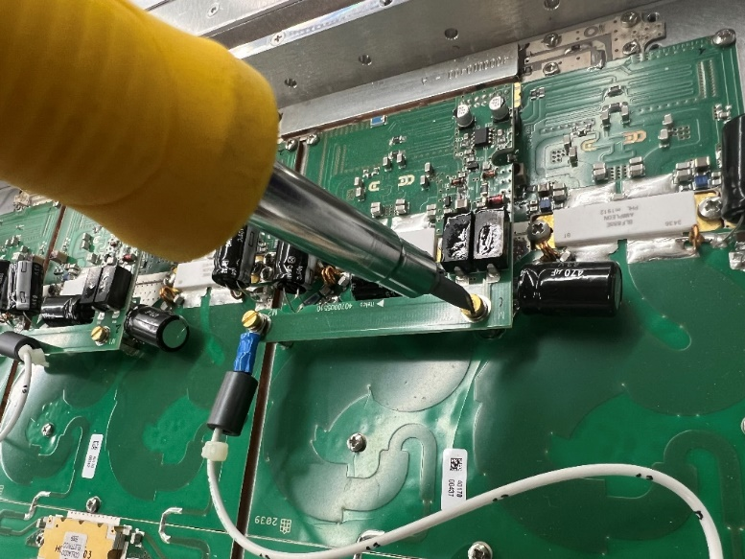
Lift bridge carefully from pallet

- Take screws out of pallet (20).
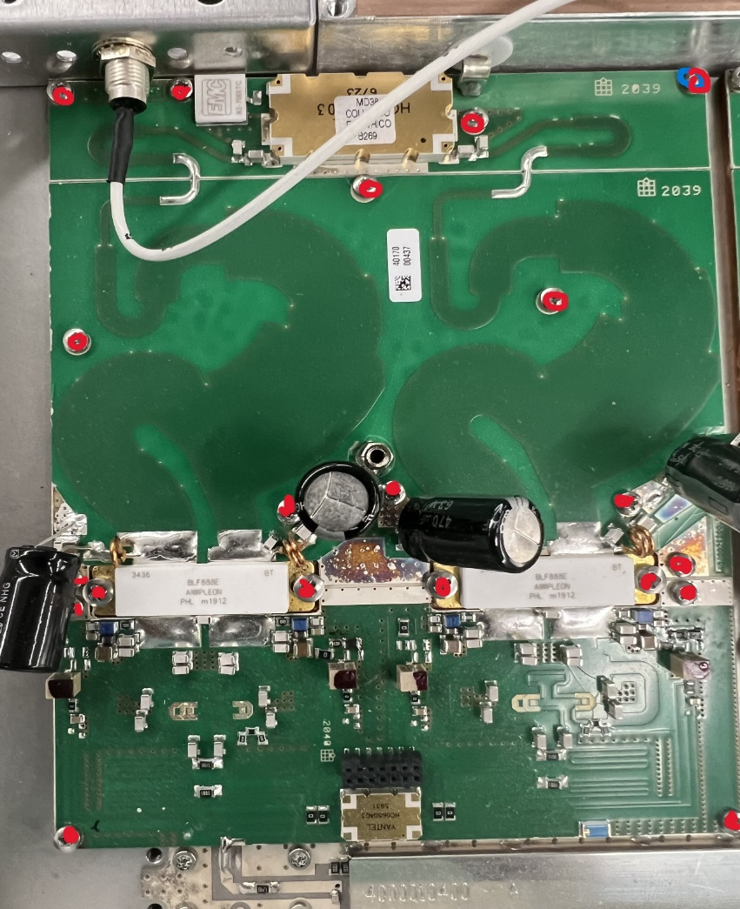

- Unsolder pallet from heat sink. 2 places.
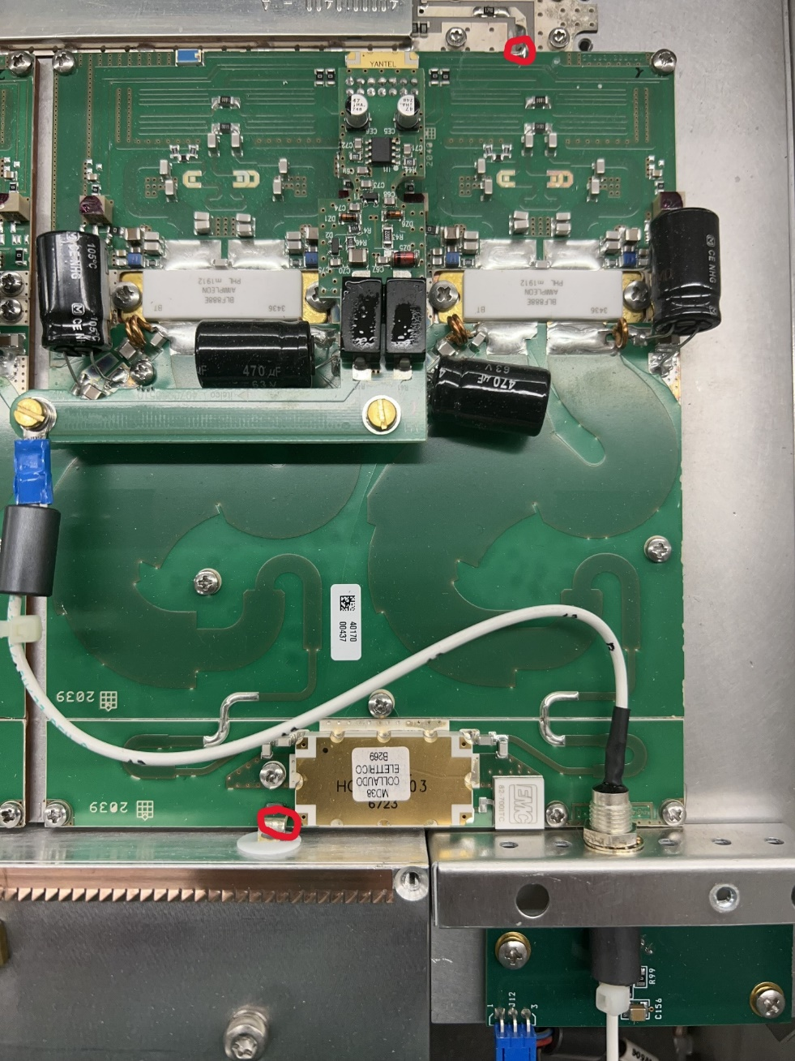
- Lift pallet from heat sink. Slightly pull back and up.

NOTE: When the pallet is off, wipe off all the heat sink compound. When installing new pallet make sure all the tape and any other debris is off the bottom.
We will be repeating previous steps backwards. Refer to same pictures in the steps above.
- Put new heat sink compound on bottom of pallet before you install. We use a thermal joint compound Type 120 Silicon. BE part # is 700-0028
- Set new pallet in place on the heatsink
- After setting pallet in place first put the 20 screws back in and leave loose until all 20 screws are started. Tighten down all 20 screws.
- Then soldier the 2 points
- Carefully put power bridge back on.
- Pallet covers next
- Then lid to the HPA.
- Check for loose hardware
HPA is ready to put back in use.

